Cognizant - DN 4.0 Deep Skilling Java FSE

Week 01 – Design Pattern and Principles

Superset ID: 6383725

Name: G Ashritha

**Exercise 1: Implementing the Singleton Pattern**

//Logger.java

public class Logger {

    private static Logger instance;

    private Logger() {

        System.out.println("Logger Initialized");

    }

    public static Logger getInstance() {

        if (instance == null) {

            instance = new Logger();

        }

        return instance;

    }

    public void log(String message) {

        System.out.println("Log: " + message);

    }

}

//LoggerTest.java

public class LoggerTest {

    public static void main(String[] args) {

        Logger logger1 = Logger.getInstance();

        logger1.log("First message");

        Logger logger2 = Logger.getInstance();

        logger2.log("Second message");

        System.out.println("Are both loggers same? " + (logger1 == logger2));

    }

}

//Output:

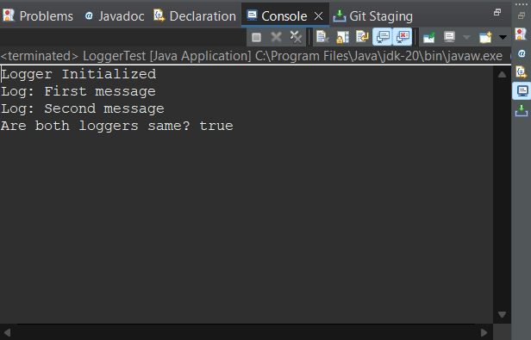

**Exercise 2: Implementing the Factory Method Pattern**

//Document.java

package documents;

public interface Document {

void open();

}

//WordDocument.java

package documents;

public class WordDocument implements Document {

public void open() {

System.out.println("Opening a Word document...");

}

}

//PdfDocument.java

package documents;

public class PdfDocument implements Document {

@Override

public void open() {

System.out.println("Opening a PDF document...");

}

}

//ExcelDocument.java

package documents;

public class ExcelDocument implements Document {

@Override

public void open() {

System.out.println("Opening an Excel document...");

}

}

//DocumentFactory.java

package documents;

public abstract class DocumentFactory {

public abstract Document createDocument();

}

//WordDocumentFactory.java

package documents;

public class WordDocumentFactory extends DocumentFactory {

public Document createDocument() {

return new WordDocument();

}

}

//PdfDocumentFactory.java

package documents;

public class PdfDocumentFactory extends DocumentFactory {

@Override

public Document createDocument() {

return new PdfDocument(); //

}

}

//ExcelDocumentFactory.java

package documents;

public class ExcelDocumentFactory extends DocumentFactory {

@Override

public Document createDocument() {

return new PdfDocument();

}

}

//Output

